The meeting was attended by Mr Andrew Elborn, AIIB ‎First Secretary at Australian Embassy in Beijing City, China; Mr. Ha Hai An, Vice Director of International Cooperation Department of the State Bank of Vietnam.
At the meeting, Deputy Governor Dao Minh Tu welcomed Mr. Chris Legg’s first visit to Vietnam. He spoke highly of Mr. Christopher Legg’s practical activity with the aim of exploring the demand of Vietnam infrastructure investment, thereby supporting Vietnam and other member countries to protect their benefit.
SBV Deputy Governor congratulated Chris Legg for being newly appointed as member of AIIB Management Board. Deputy Governor affirmed that Vietnam appreciates his proficiency and commitment via his valuable and positive contribution to policy and operational procedures formulation of the SBV.
Deputy Governor Dao Minh Tu briefed his guest the infrastructure demand and priority of infrastructure investment of Vietnam. He said the Government of Vietnam is accelerating the progress of mechanism completion and creating the favourable environment to attract more investors in infrastructure and private sector. Deputy Governor expressed his hope that AIIB will soon finalize the selection of appropriate projects for Vietnam which secure economic effectiveness and the target of maintaining sustainable public debt as well.
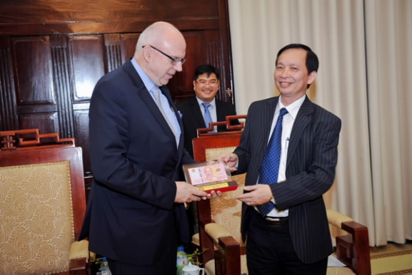
Expressing his great gratitude to SBV’s support the Group over the past time, Mr. Chris Legg congratulated the encouraging socio-economic achievements of the Government of Vietnam and the SBV with the aim of becoming a middle-income country. Mr. Chris Legg appreciated effective contribution of Vietnam as a responsible partner in the progress of upgrading policy mechanisms, organization and operation of AIIB.
Chris Legg, for his part, said that based on investment demand and policies of Vietnam, and he, on behalf of the Group, will continue supporting and accompanying Vietnam to access AIIB’s loans and co-financing effectively.

Nguyen Giang

