The ceremony was attended by SBV Deputy Governor Pham Quang Dzung, representatives from the Human Resources Department, representatives of the different units under the Banking Supervision Agency, and all of the officials of Department II of the Banking Supervision Agency.
At the ceremony, a representative from the SBV Human Resources Department announced the SBV Governor’s Decision appointing Ms. Nguyen Thi Thu Huong as Acting Director of Department II of the Banking Supervision Agency. Ms. Nguyen Thi Thu Huong was previously Deputy Director of Department II of the Banking Supervision Agency.
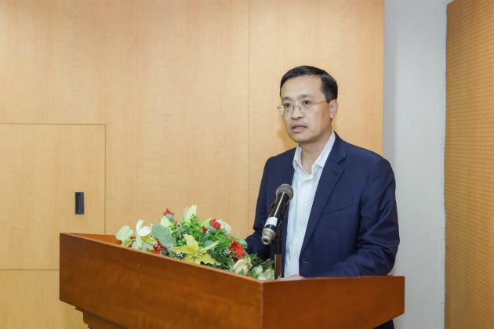
Deputy Governor Pham Quang Dzung speaks at the ceremony
Speaking at the ceremony, Deputy Governor Pham Quang Dzung congratulated Ms. Nguyen Thi Thu Huong on her new appointment. He expressed his hope and beliefs that Ms. Nguyen Thi Thu Huong would continue to develop her capacity, wisdom, experience, and the sense of responsibility to accomplish the assigned tasks in her newly appointed position.
In her statement of gratitude, Ms. Nguyen Thi Thu Huong promised to do her best to contribute to the development of both the SBV and the banking sector.
Le Hang

